Istanbul Guide
This is a guide to the European side of Istanbul. There are a lot of good places on the Asian side too, but I don’t know enough to include them here.

General Info and Getting Around 1
Café’s and Restaurants by Area 3
Ortaköy 3
Karaköy 3
Taksim Square / Istiklal Street / Beyoglu 4
Sultanahmet 5
Bebek 6
More High End Dining 6
Nightlife 7
Shopping 8
Other activities 8
Emergency Doctor 9

General Info and Getting Around

Travel from Airports to Taksim square – There is a good coach service every 30 minutes between the airports and Taksim square. It costs 10 Lira from Istanbul Ataturk Airport to Taksim (journey takes 45 minutes) and 12 Lira from Sabiha Gokcen Airport to Taksim (journey takes 60-90 minutes)

Look for the Havataş buses once you exit the arrivals lounge or just ask anyone for the Havataş Bus to Taksim.

The two most popular hubs on the European side of Istanbul are:

- Sultanahmet - a lot of the historical sites are located here (Sultanahmet Mosque, Hagia Sophia, Topkapi Palace, etc)

- Taksim / Beyoglu / Istiklal Street - where shops, café’s, bars and nightlife are concentrated. Istiklal Street is a pedestrian avenue which branches off from Taksim Square.

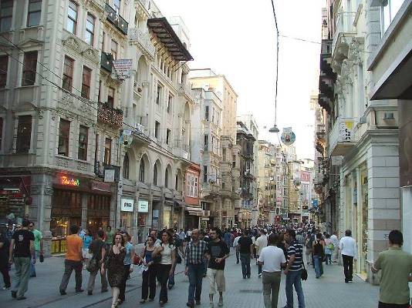
Istiklal street, in Beyoglu/Taksim

You can travel between the 2 centres quite easily using public transport. To go from Taksim to Sultanahment:

  - Take the funicular from Taksim Metro station to Kabataş.
  - At Kabataş, take the tram to Sultanahmet.

The journey takes about 20 minutes.

If you have some more time, there are other, less touristy areas of the city well worth a visit. The best ones are:

- Ortaköy – This is a 15 minute taxi or bus ride from Taksim. It’s on the sea side and a pleasant area to walk around with loads of street stalls selling jewellery and art. You can find good street food too. Here you can also do an hour long boat tour of the Bosphorus for 10 Lira.

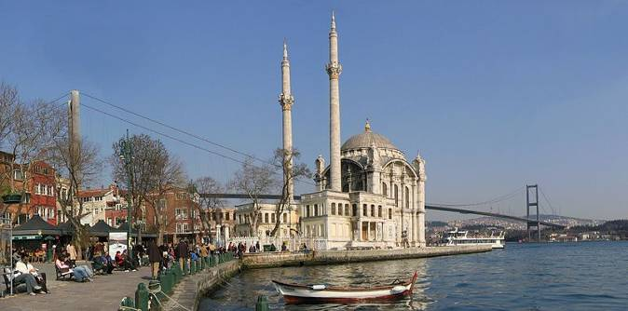
Ortakoy

- Bebek – Many of Istanbul’s young come here to party. Loads of bars, restaurants and cafes with great views of the Bosphorus. Closest metro station is Levent. When exiting the metro station, follow the signs to Levent Carsi and then take a taxi from there. It’s about a 10 minute taxi ride.

- Nistantasi - This is probably the most elite shopping district of Istanbul. A lot of designer shops are located here. There are also plenty of street café’s. Abdi Ipekci Caddesi and Atiye sokak are great streets for walking around. Closest metro station is Osmanbey. When exiting the station, follow the signs to Rumeli. Abdi Ipekci Caddesi is a 10 minute walk from the station. Alternatively, hop into a Dolmus (yellow mini bus) they leave from Taksim square and take you to the heart of Nistantasi in about 10 minutes).

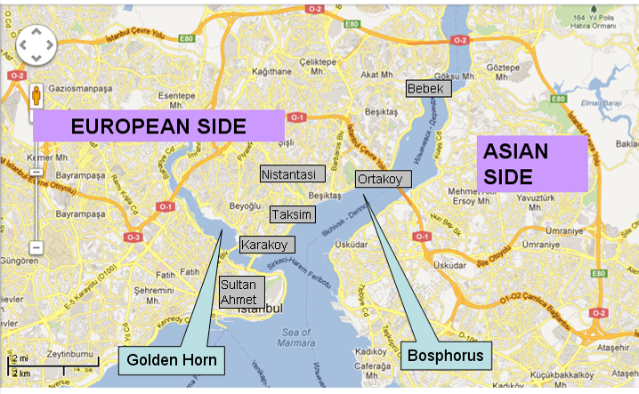

Taxis
All the taxis are metered but about half of them will attempt to rip you off by taking a much longer route than necessary. Also beware when paying the fare: if you hand over a 50 lira note, a very common trick is for the driver to claim that you only gave him a 5 lira note. Both notes are the same colour and look very similar and you can easily mix them up.

Café’s and Restaurants by Area

Ortaköy

- Aşk Café (pronounced Ashk Café) It’s on the Bosphorus, near an area called Ortakoy. They have good salads and sandwiches and a nice Ayran (Turkish drink made up of yoghurt + water + salt)
Address: Muallim Naci Cadesi No. 170/A Kurucesme Tel: (0212) 265 47 34.

- The House Café - They have branches all over Istanbul, they have an international food menu with a Turkish twist. Their branch in Ortakoy is in a very nice setting.
Address: Ortaköy Salhane Caddesi no. 1 Ortaköy Tel: (0212) 227 2639

Karaköy

- Lokanta Maya - Highly recommended. Delicious Turkish dishes and Mediterranean dishes, the food is very fresh and the setting is quite trendy.
Address: Kemankeş Caddesi 35/A, Karaköy, , www.lokantamaya.com, Open Tue-Sat noon-5pm and 7pm-11pm, Mon lunch only. Tel: (0212) 252 68 84

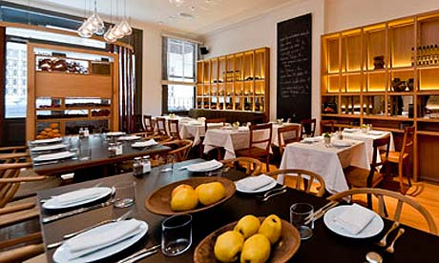
Maya

- Gulluoglu - This place only does desserts, and specialises in Baklava. Although you’ll find pretty good baklava all over Istanbul, these guys take special pride in theirs. They’ve been doing it for over 100 years and you’ll find varieties that you wont come across in other places.
Address: Karaköy, Mumhane Cad. No: 171. Closest tram station: Karakoy

Taksim Square / Istiklal Street / Beyoglu

- Leb-i-derya - Highly recommended. Great roof top restaurant and bar, really good Turkish and international food with fantastic sea views. Its better to make a reservation in advance if going on a weekend. There are two branches that are very close to each other, one is on the roof of the Richmond hotel on Istiklal street and the other is down a side street off Istiklal street called Kumbaracı Yokuşu. The second one is a bit nicer. Closest metro station: Sishane. Can walk there from Taksim Square station too.

Address: Kumbaracı Yokuşu 57/6 Tünel, Beyoğlu, Tel: (0212) 293 49 89 (0212) 243 95 55, info@lebiderya.com http://www.lebiderya.com/

- Antiochia – This is a very small charming restaurant which serves food from the southern region of Turkey. Their portions are quite small but the food is very tasty. The minced meat dürüm (wrap) with onions and tomatoes is delicious. Closest Metro Station: Sishane

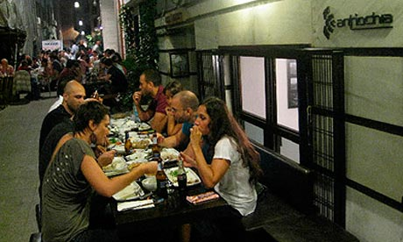
Antiochia

Address: Minare Sokak 21, Beyoğlu, +90 212 292 1100, www.antiochaconcept.com , Open Mon-Fri noon-midnight, Sat 3pm-midnight

- Asmali Mescit – (pronounced Asmaal-i Mes-jit). This is at the very bottom of Istiklal street, its small but the area has some interesting streets, and coffee shops that make for a pleasant break from all the walking in the city.

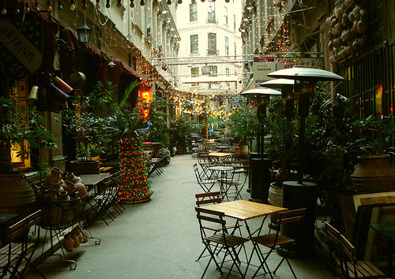
Asmali Mescit

- Cezayir Sokagi also known as Fransiz Sokagi (Algerian Street, aka French Street) - A historical street renovated with lots of café’s and restaurants. It is off Istiklal street.

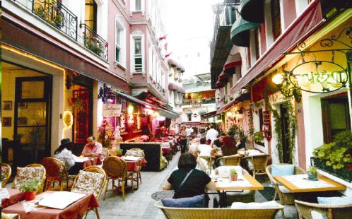
Fransiz Sokagi

- Kitchenette – They have branches all over the city, the menu is similar to The House Café. There is a branch on Taksim square, located on the ground floor of the Marmara hotel, within 1 minute walk of the Taksim metro station, you can’t miss it. They have a good variety of Turkish and international food, reasonable prices.

Sultanahmet

- Sultanahmet Koftecisi - The restaurants in the Sultanahmet area are quite touristy and the food isn’t that great but this place is pretty good. They’ve been open since 1920 and the only items on their menu are: Kofte (Turkish meatballs), beans, salad and a dessert. It’s not fine dining, more like an express diner.

They’re located on one of the sides of the Sultanahmet square. There are actually two different restaurants which have this name, and they are 20m apart, one of them is a copy of the original. The original looks like the photo below from the outside.

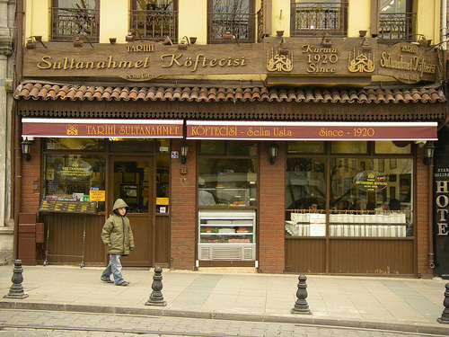
Sultanahmet Koftecisi (the original one!)
.

- Karakol – This is located inside the Topkapi Palace, it used to be a former Ottoman police station. Their food is classic Ottoman style, I’ve haven’t been but I’ve heard good things about it. Their feta cheese sea bass is meant to be really good, its cooked with shrimp and tomato sauce and serviced with melted feta.

Bebek

There are countless restaurants, café’s and bars along the seaside boulevard in Bebek. A good one is a bar/restaurant called Chilai.

- Chilai – Located right on the seaside, this restaurant has 3 levels and all have great views of the Bosphorus. The ground floor becomes like a bar after 11pm. They have a mixture of Turkish and international dishes. Their portions are quite large. Closest metro station: Levent (Not 4. Levent) and follow exit signs to Levent Carsi. It’s then a 10-15 minute taxi ride from there.

Address: Cevdetpasa Caddesi, No. 60, Bebek. Tel: (0212) 263 63 15. www.chilai.com.tr

More High End Dining

Venge - Highly recommended. They specialise in Turkish mezze and kebabs, it’s better for dinner rather than lunch. For starters, they will bring over a big tray with different dishes and you just tell the waiter which ones you want. (Closest Metro station: 4.Levent, you’ll need a taxi from there).
Address: Akaysali Sokak 2, 4.Levent Tel: (0212) 281 93 83

Ulus 29
Highly recommended. This is a very chic restaurant with fantastic views of the Bosporus, great food, but pretty expensive. ($40-70 per person excluding alcohol).
Address: 1 Kireçhane Sokak, Adnan Saygun Caddesi, Ulus Parkı, Ulus. Tel: 0212 265 6181
http://www.timeout.com/istanbul/restaurants-cafes/venue/16946/ulus-29

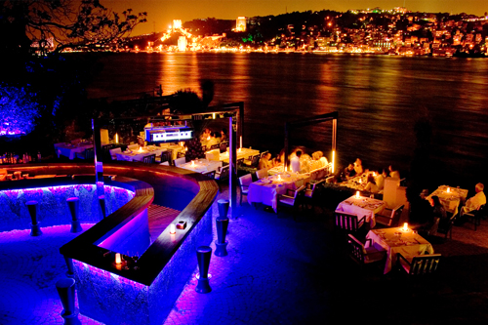
Ulus 29

Angelique
Located in Ortaköy, top quality restaurant and bar, they have an international menu. Getting in during busy periods is sometimes difficult, its best to make a reservation.
Address: Muallim Naci Caddesi, Salhane Sokak, 5 Ortaköy. Tel: (0212) 327 2845

360 Restaurant and bar – Located in the Beyoglu/Istiklal street area, they have good views. Better for drinks rather than food, a little pretentious. Leb-i - derya is probably better.
Address: 32–309 Istiklal Caddesi, Misir Apt. K8, Beyoglu. Tel: (0212) 251 10 42

Nightlife

Reina (night club with several restaurants inside)
Address: Muallim Naci Caddesi 10 Ortaköy, Tel (0212) 259 5919
There are about 10 different restaurants here, a few bars, and it becomes a nightclub later in the evening. If going on a weekday, its best to get there early because a new rule requires them to block off the view with a sound proof curtain after midnight.

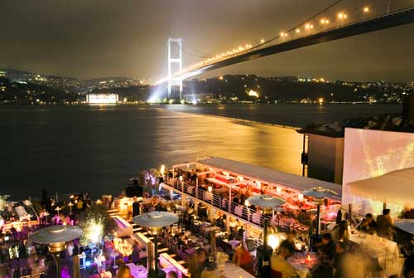
Reina

Shopping

Grand Bazaar (Kapali Çarşi in Turkish) – 4000+ shops selling jewellery, leather, carpets, one of the oldest shopping markets in the world. Usually closed during the first 2 days of Eid.

Spice Market (known as Misir Çarşisi in Turkish)

Nistantasi - high end outdoor shopping area, mentioned in the general info section above.

Malls

- Istinye Park. Probably the best mall in Istanbul and it has a beautiful outdoor area with loads of restaurants. The closest metro station is İTÜ Ayazağa and then a 10 minute taxi ride.

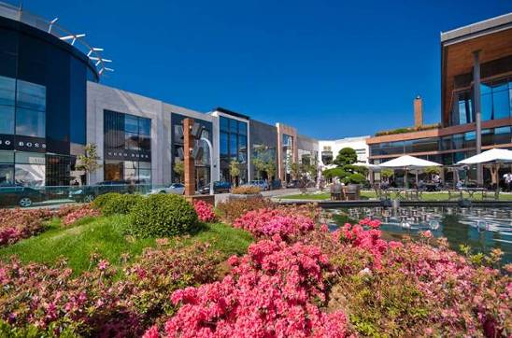

- Kanyon – Another high end attractive mall, the aisles are open air but the shops are covered. Can be accessed directly from the Levent metro station

- Cevahir – Huge mall but always extremely crowded. Direct access from Sisli / Mecidiyekoy metro station.

Other activities

Bosphorous Boat Tour –High recommended There are boats that offer an hour long Bosphorous tour from the pier at Ortakoy (see above). The tour costs about 15 lira ($10) and is great way to see Istanbul by sea, especially if the weather is good. Boats leave every 15 minutes or so.

Buyuk Ada (aka Princess Island) – This is an island in the Marmara sea, it takes about an hour to get to by boat. It’s a nice place to visit for a day out if the weather is good and if you like cycling, you can rent a bike and cycle around the whole island. There are no cars on the island, you can only get around by foot, bicycle or horse drawn carriages.

Dolmabahce Palace
Very well maintained palace Ottoman Palace near Ortakoy. Ataturk died in one of the rooms here.

Istanbul Modern – Karakoy – This is quite a good modern artmuseum. The cafe also has good food and a wonderful view of the Bosporus. Info on what’s on display can be found at: http://www.istanbulmodern.org/

Emergency Doctor
Dr. Dogan Basak, Mob: +90 532 212 27 94

Very professional and reliable doctor, I’ve known him since 1990. He works at the Surp Agop Hospital, just off Taksim Square.

Surp Agop Hastanesi
Yedikuyular Cad. No. 6/1
Elmadag, Taksim
Tel: +90 212 230 17 18

More information

Best High End Restaurants in Istanbul
http://www.guardian.co.uk/travel/2011/sep/14/10-best-high-end-restaurants-istanbul

For more on eating options in Istanbul, check out: http://istanbuleats.com/

